**Note Keeping App:**

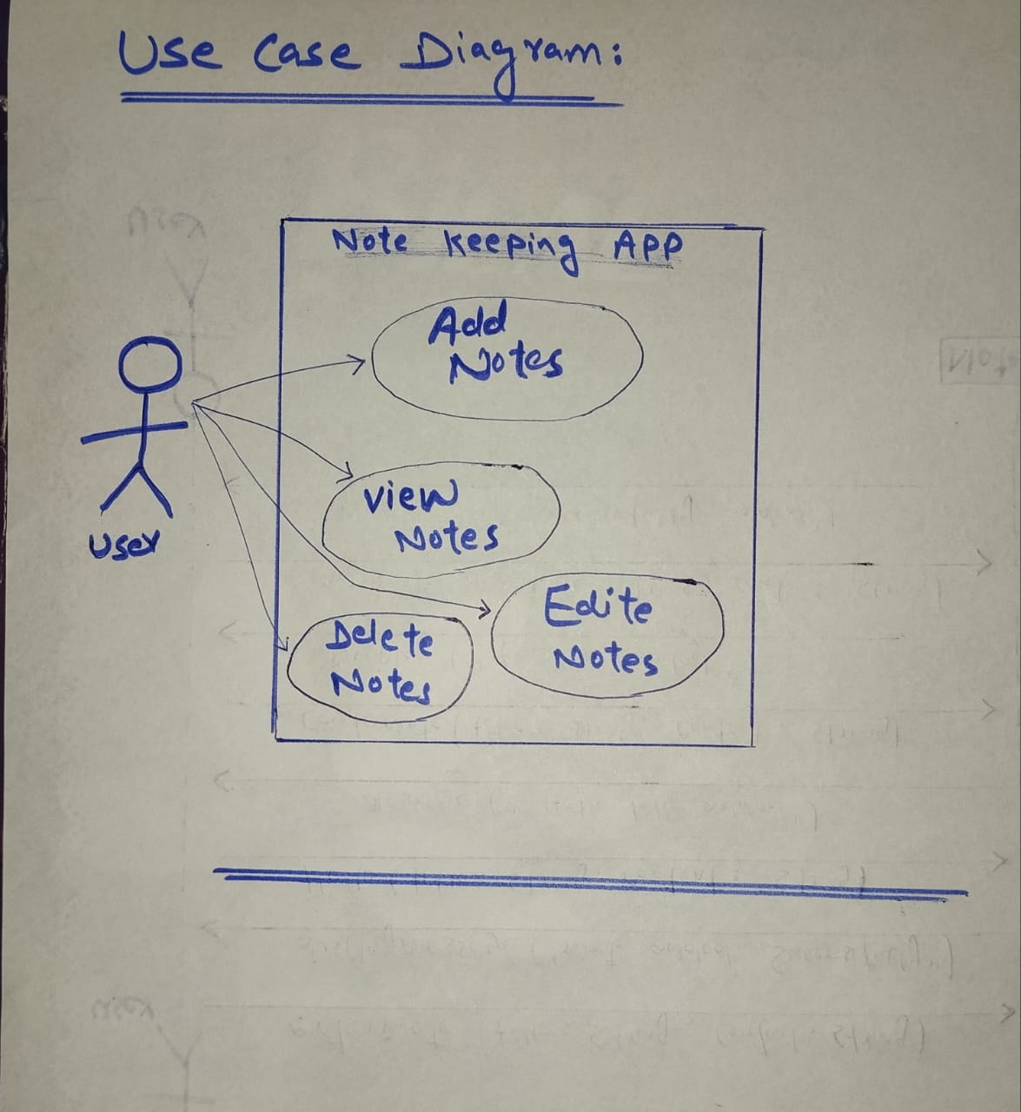

**Use Case: Add Note:**

**Primary Actor**

* User: The individual who wants to create and store notes using the note-keeping application.

**Pre-Conditions**

* The application must be running and accessible on the user’s device.
* The user must have a valid title and content to add to the note.

**Post-Conditions**

* The note is successfully created and stored in the system.
* The user receives confirmation that the note has been added.
* The new note appears in the user's list of notes.

**Success Scenario**

1. User Input: The user enters a title and content for the note.
2. Application Processing:
   * The note-keeping application validates the input.
   * The application creates a new note object with the provided title and content.
   * The application saves the note to the database or storage.
3. Confirmation: The application displays a message: "Note added successfully!".
4. Result: The new note appears in the user's notes list.

**Alternative Scenarios**

1. Missing Title:
   * User Input: The user enters content but leaves the title empty.
   * Application Response: The application validates the input and detects the empty title.
   * Error Message: The application displays a message: "Note title cannot be empty!".
   * The user can then enter a valid title.
2. Missing Content:
   * User Input: The user enters a title but leaves the content empty.
   * Application Response: The application validates the input and detects the empty content.
   * Error Message: The application displays a message: "Note content cannot be empty!".
   * The user can then enter valid content.
3. **Invalid Input Format:**
   * User Input: The user enters a title or content that contains disallowed characters or exceeds the maximum length.
   * Application Response: The application validates the input and detects the invalid format.
   * Error Message: The application displays a message: "Invalid input format!".
   * The user can correct the input.

**System Sequence Diagram:**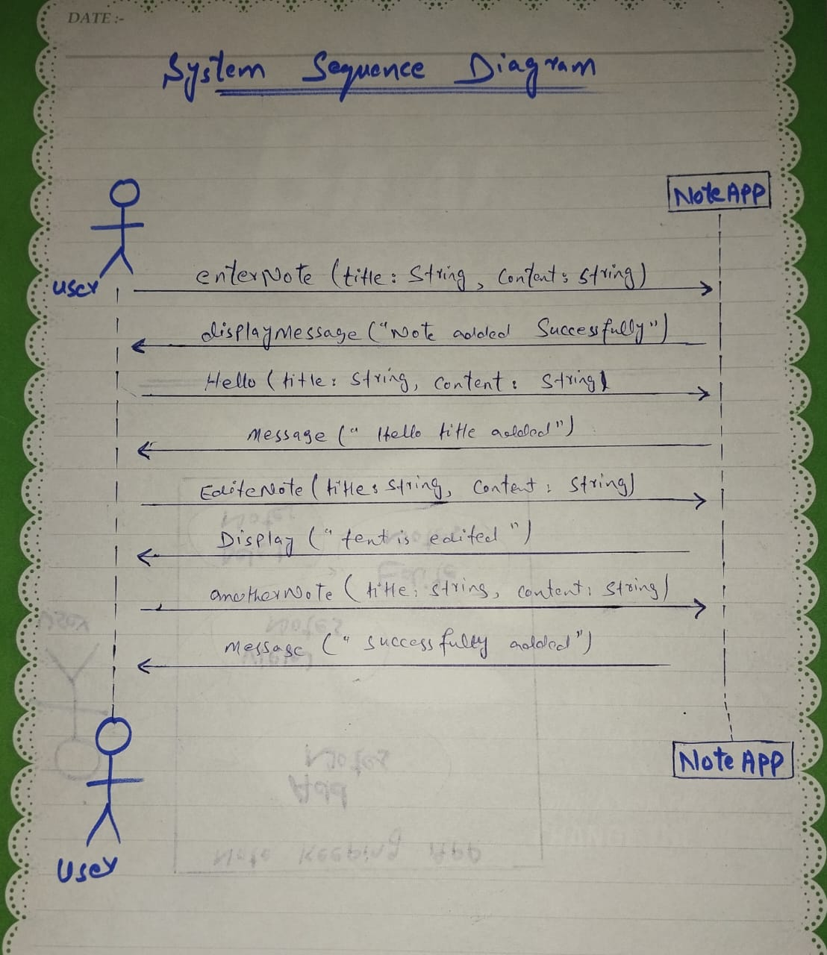

**Communication Diagram:**

**Class Diagram:**

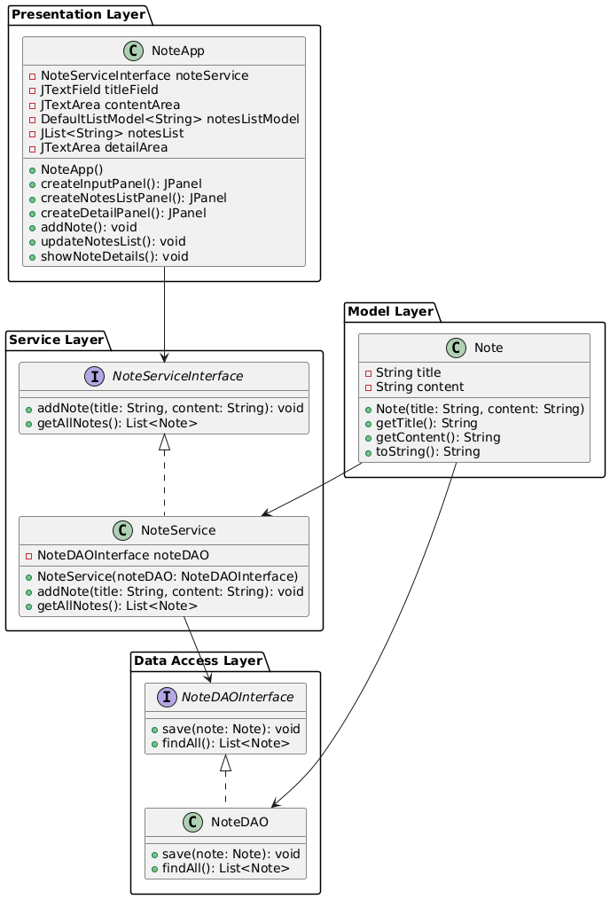

**Package Diagram:**

